1. html

<!DOCTYPE html>

<html lang="en">

<head>

<meta charset="UTF-8">

<meta name="viewport" content="width=device-width, initial-scale=1.0">

<title>My First HTML Page</title>

</head>

<body>

<h1>Welcome to HTML</h1>

<p>This is a basic HTML document.</p>

</body>

</html>

**Out put:**

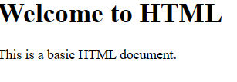

2.creating list:

<!DOCTYPE html>

<html lang="en">

<head>

<meta charset="UTF-8">

<meta name="viewport" content="width=device-width, initial-scale=1.0">

<title>Lists Example</title>

</head>

<body>

<h2>Ordered List - Programming Languages</h2>

<ol>

<li>Python</li>

<li>JavaScript</li>

<li>Java</li>

</ol>

<h2>Unordered List - Fruits</h2>

<ul>

<li>Apple</li>

<li>Banana</li>

<li>Orange</li>

</ul>

</body>

</html>

**Output:**

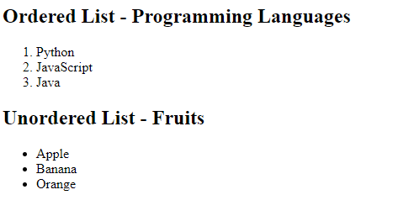

3.Adding images

<!DOCTYPE html>

<html lang="en">

<head>

<meta charset="UTF-8">

<meta name="viewport" content="width=device-width, initial-scale=1.0">

<title>Image Example</title>

</head>

<body>

<h2>My Favorite Image</h2>

<img src="your-image-url.jpg" alt="A beautiful landscape with mountains and a lake" width="500">

</body>

</html>

**Out put:**

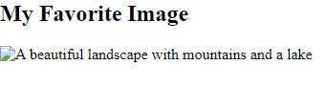

**4.**Semantic HTML:

<!DOCTYPE html>

<html lang="en">

<head>

<meta charset="UTF-8">

<meta name="viewport" content="width=device-width, initial-scale=1.0">

<title>Internal Hyperlinks</title>

</head>

<body>

<h2>Internal Hyperlinks</h2>

<!-- External hyperlink -->

<p><a href="https://www.example.com">External Link</a></p>

<!-- Internal hyperlink to a specific section -->

<p><a href="#section2">Jump to Section 2</a></p>

<h3 id="section1">Section 1</h3>

<p>This is the content of Section 1.</p>

<h3 id="section2">Section 2</h3>

<p>This is the content of Section 2. <a href="#section1">Go back to Section 1</a></p>

</body>

</html>

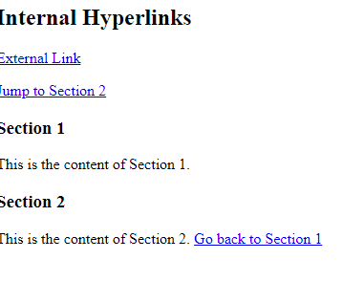

**5.**Using forms:

<!DOCTYPE html>

<html lang="en">

<head>

<meta charset="UTF-8">

<meta name="viewport" content="width=device-width, initial-scale=1.0">

<title>User Information Form</title>

</head>

<body>

<h2>User Information Form</h2>

<form action="#" method="post">

<label for="name">Name:</label>

<input type="text" id="name" name="name" required><br><br>

<label for="gender">Gender:</label><br>

<input type="radio" id="male" name="gender" value="male">

<label for="male">Male</label><br>

<input type="radio" id="female" name="gender" value="female">

<label for="female">Female</label><br>

<input type="radio" id="other" name="gender" value="other">

<label for="other">Other</label><br><br>

<label for="country">Country:</label>

<select id="country" name="country">

<option value="USA">USA</option>

<option value="Canada">Canada</option>

<option value="UK">UK</option>

<option value="Australia">Australia</option>

</select><br><br>

<input type="submit" value="Submit">

</form>

</body>

</html>

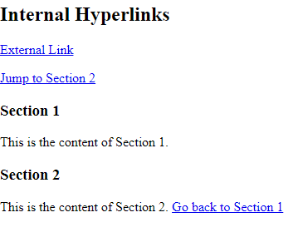

**6th**

<!DOCTYPE html>

<html lang="en">

<head>

<meta charset="UTF-8">

<meta name="viewport" content="width=device-width, initial-scale=1.0">

<title>User Information Table</title>

</head>

<body>

<h2>User Information Table</h2>

<table border="1">

<tr>

<th>Name</th>

<th>Age</th>

<th>City</th>

</tr>

<tr>

<td>John Doe</td>

<td>30</td>

<td>New York</td>

</tr>

<tr>

<td>Jane Smith</td>

<td>25</td>

<td>Los Angeles</td>

</tr>

</table>

</body>

</html>

**7th**

<!DOCTYPE html>

<html lang="en">

<head>

<meta charset="UTF-8">

<meta name="viewport" content="width=device-width, initial-scale=1.0">

<title>Enhanced HTML Document</title>

</head>

<body>

<header>

<h1>My First HTML Page</h1>

</header>

<article>

<h2>Welcome to HTML</h2>

<p>This is a basic HTML document.</p>

</article>

<footer>

<p>&copy; 2024 My Website. All rights reserved.</p>

</footer>

</body>

</html>

**8th**

<!DOCTYPE html>

<html lang="en">

<head>

<meta charset="UTF-8">

<meta name="viewport" content="width=device-width, initial-scale=1.0">

<title>Enhanced HTML Document with Multimedia</title>

</head>

<body>

<header>

<h1>My First HTML Page</h1>

</header>

<article>

<h2>Welcome to HTML</h2>

<p>This is a basic HTML document.</p>

</article>

<footer>

<p>&copy; 2024 My Website. All rights reserved.</p>

</footer>

<audio controls>

<source src="your-audio-file.mp3" type="audio/mp3">

Your browser does not support the audio element.

</audio>

<video width="320" height="240" controls>

<source src="your-video-file.mp4" type="video/mp4">

Your browser does not support the video element.

</video>

</body>

</html>

**9th**

<!DOCTYPE html>

<html lang="en">

<head>

<meta charset="UTF-8">

<meta name="viewport" content="width=device-width, initial-scale=1.0">

<title>User Information Form</title>

</head>

<body>

<header>

<h1>User Information Form</h1>

</header>

<article>

<form action="#" method="post">

<label for="name">Name:</label><br>

<input type="text" id="name" name="name" required><br><br>

<label for="gender">Gender:</label><br>

<input type="radio" id="male" name="gender" value="male">

<label for="male">Male</label><br>

<input type="radio" id="female" name="gender" value="female">

<label for="female">Female</label><br>

<input type="radio" id="other" name="gender" value="other">

<label for="other">Other</label><br><br>

<label for="country">Country:</label><br>

<select id="country" name="country">

<option value="USA">USA</option>

<option value="Canada">Canada</option>

<option value="UK">UK</option>

<option value="Australia">Australia</option>

</select><br><br>

<input type="submit" value="Submit">

</form>

</article>

<footer>

<p>&copy; 2024 My Website. All rights reserved.</p>

</footer>

</body>

</html>

**10th**

<!DOCTYPE html>

<html lang="en">

<head>

<meta charset="UTF-8">

<meta name="viewport" content="width=device-width, initial-scale=1.0">

<title>Exploring HTML5 Features</title>

</head>

<body>

<header>

<h1>Exploring HTML5 Features</h1>

</header>

<section>

<h2>Main Content Section</h2>

<p>This is the main content of the page.</p>

<figure>

<img src="your-image-url.jpg" alt="A beautiful landscape with mountains and a lake">

<figcaption>A beautiful landscape with mountains and a lake</figcaption>

</figure>

</section>

<aside>

<h2>Additional Information</h2>

<p>This is some additional information placed in the aside section.</p>

</aside>

<footer>

<p>&copy; 2024 My Website. All rights reserved.</p>

</footer>

</body>

</html>